LVMR website modifications

- Delete the dark effect on the background on the first section of each page and change the colors of the writing :
- Black and gold for premium page
- Black and green for environnment page
- Black and grey for group page
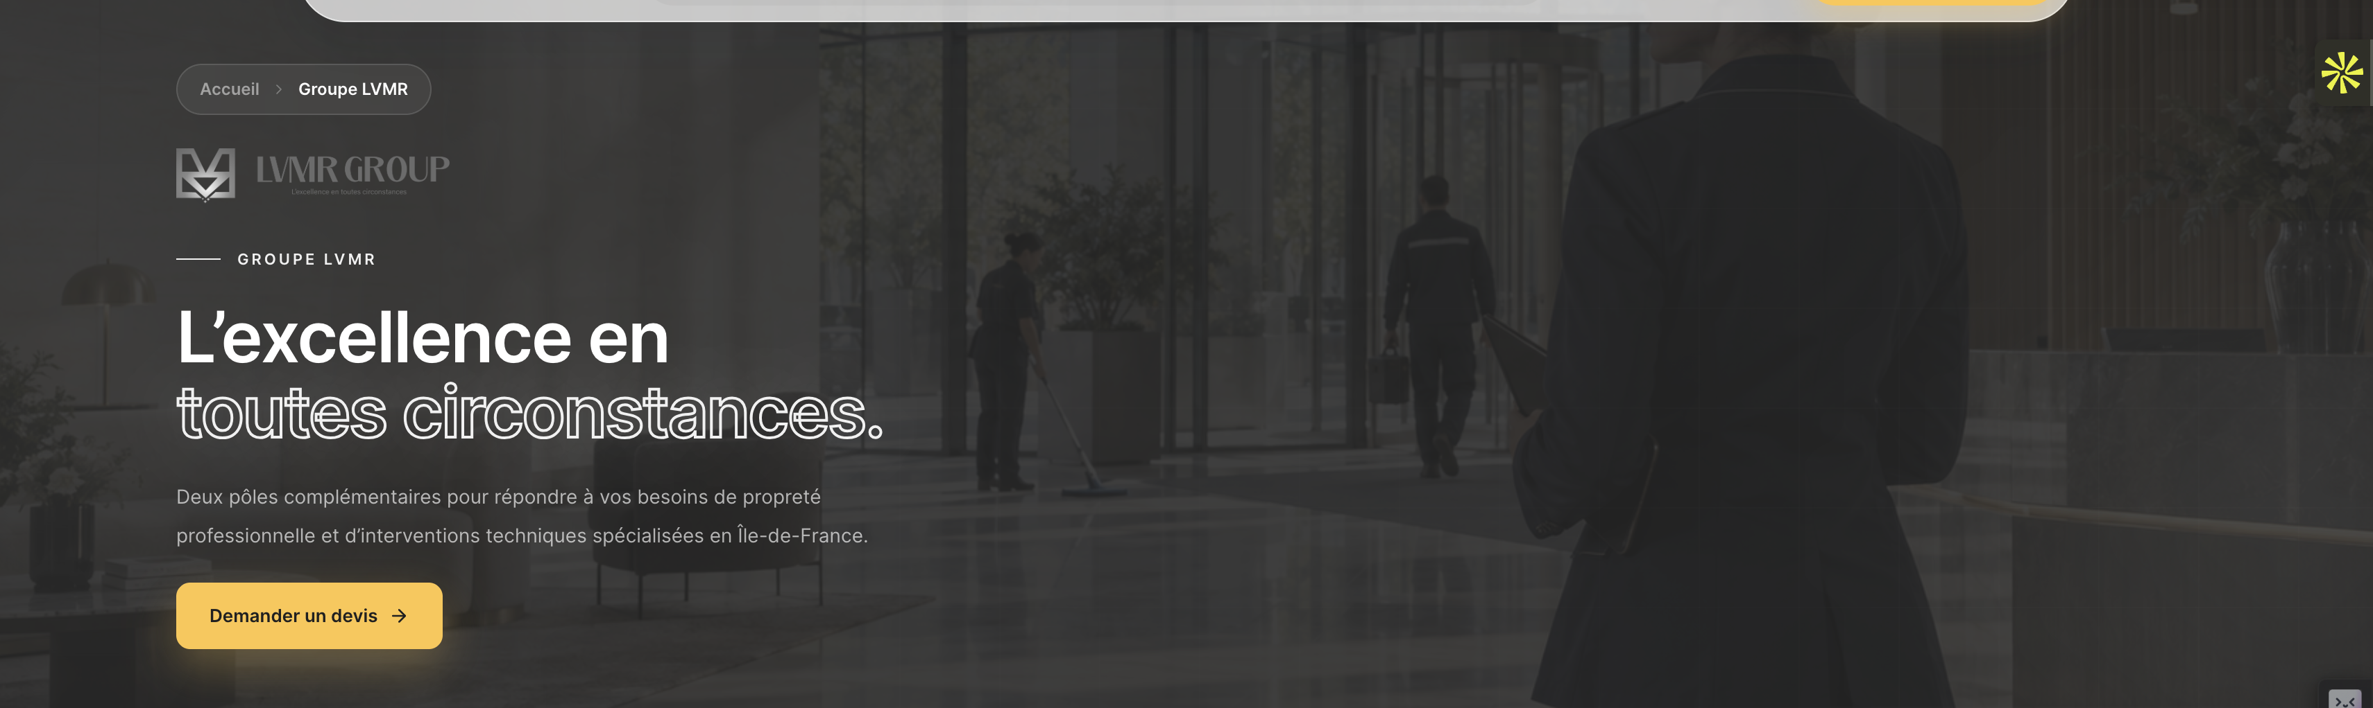

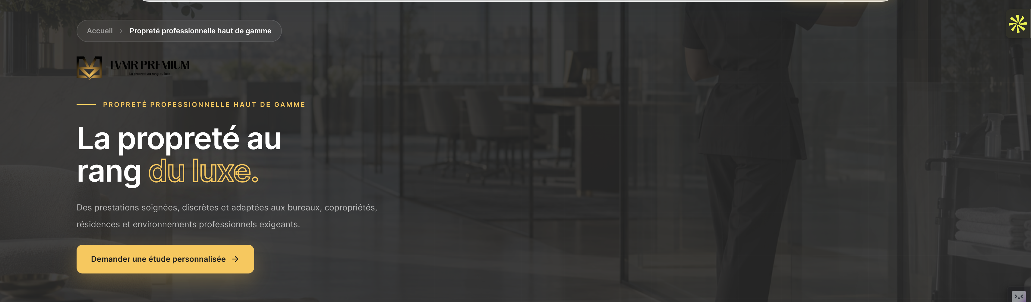

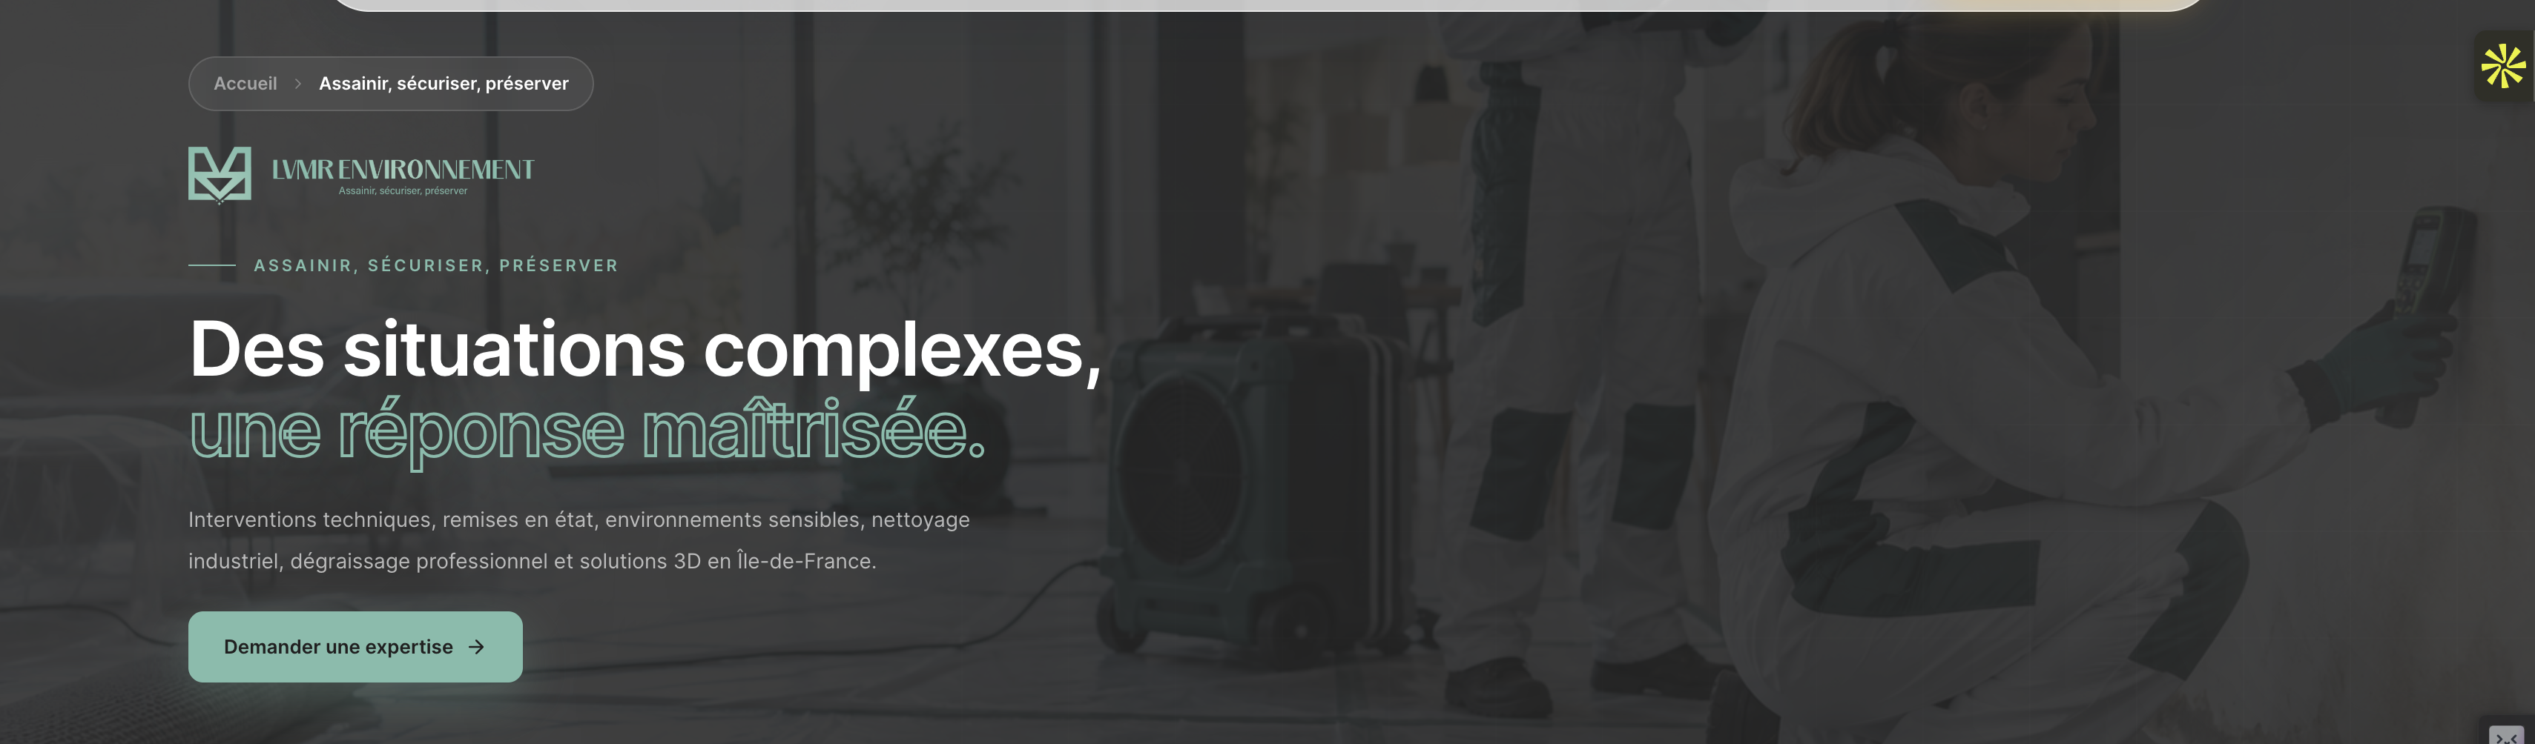

- Change this photo
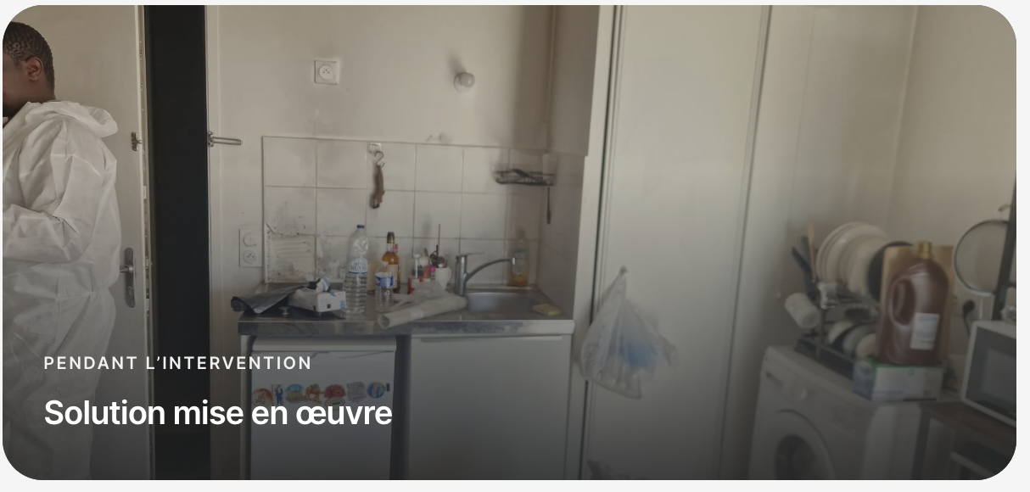

With this one
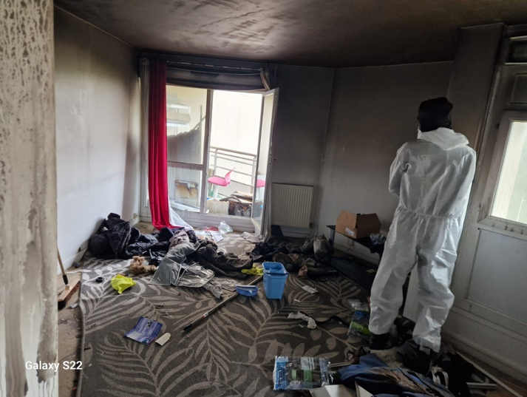

- Put the logo on black and yellow
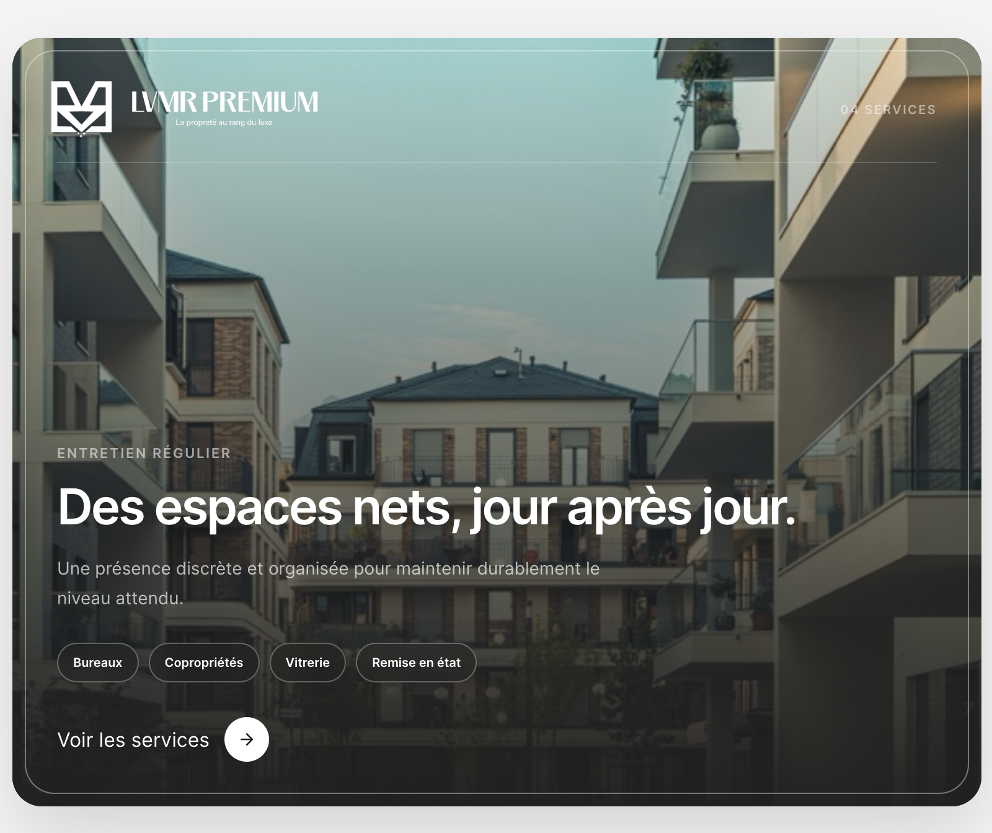

- Add « expert d’assurance »
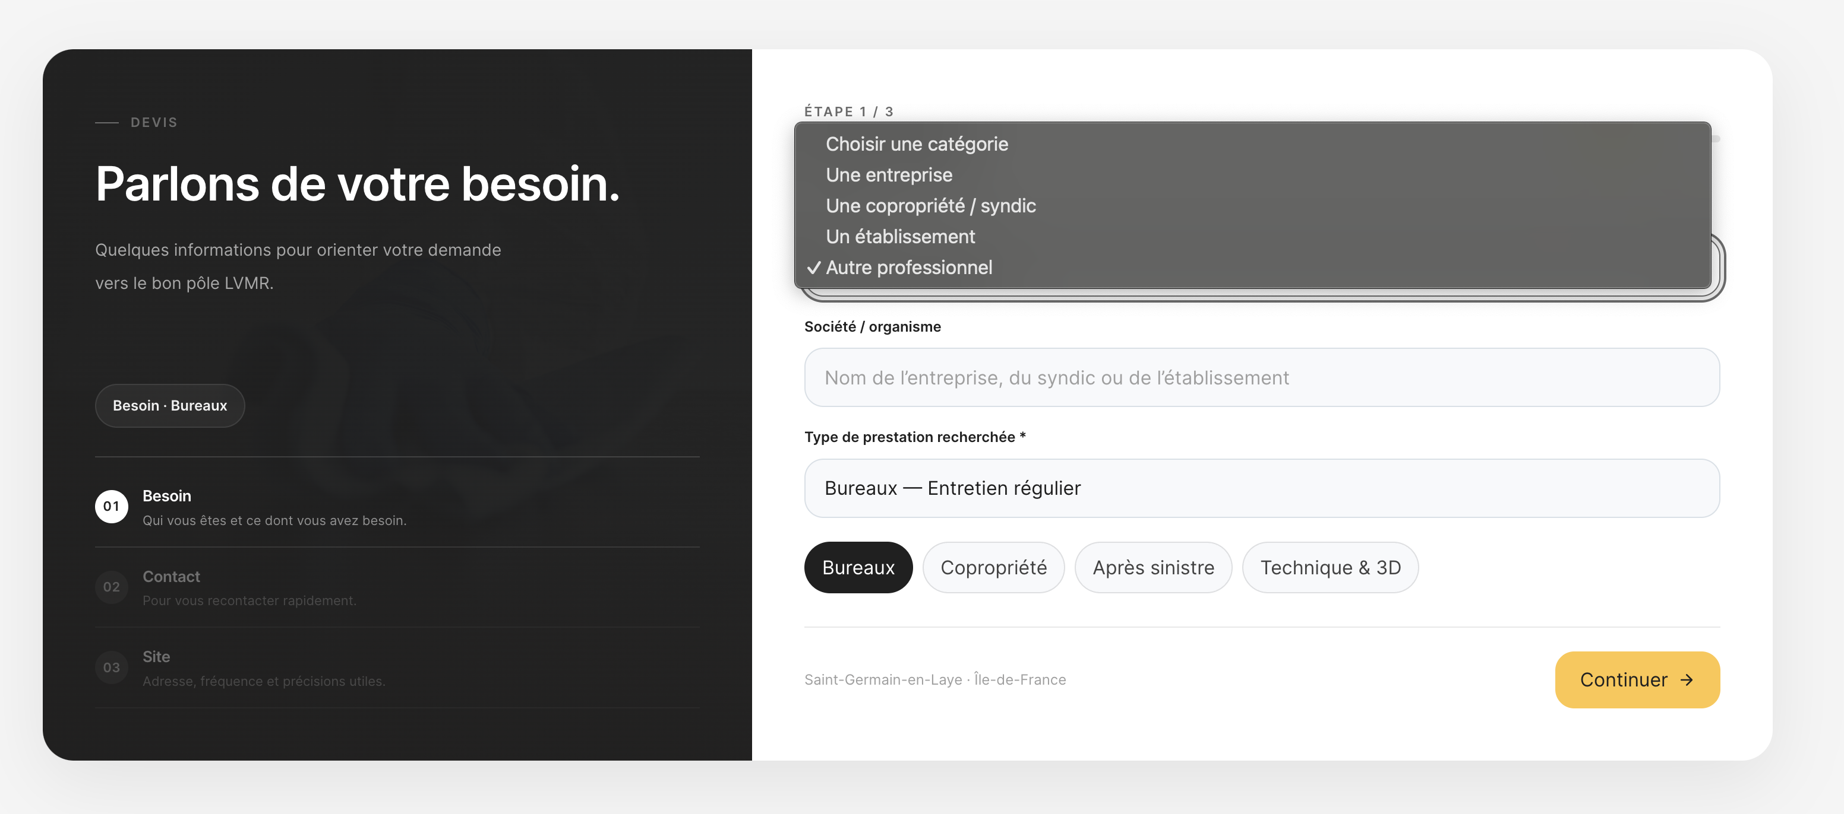

- Change this photo
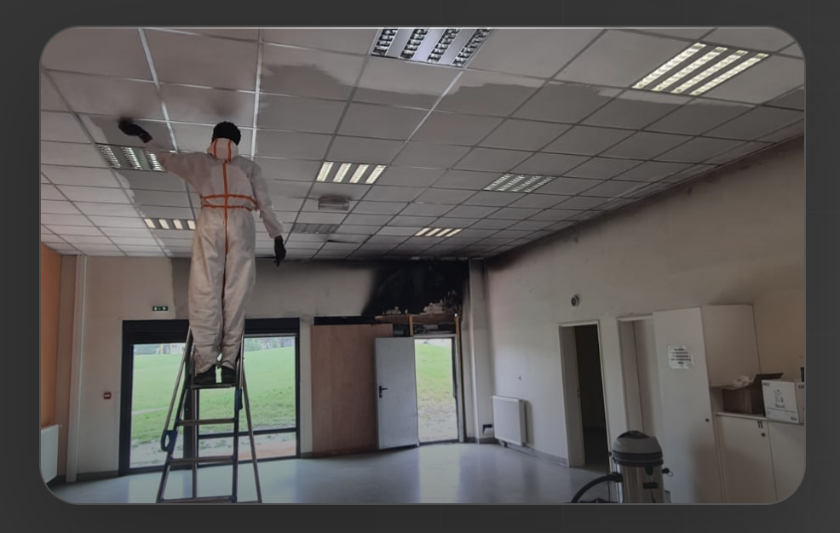

By the one named « NOS REALLLLL » on the drive

- Change these photos
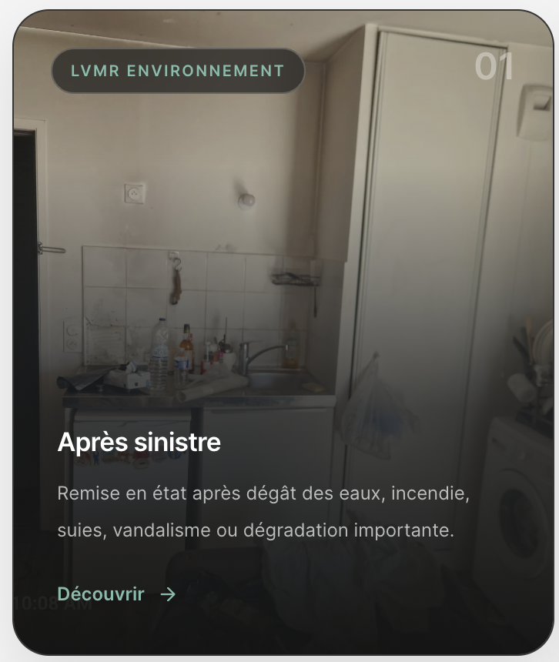
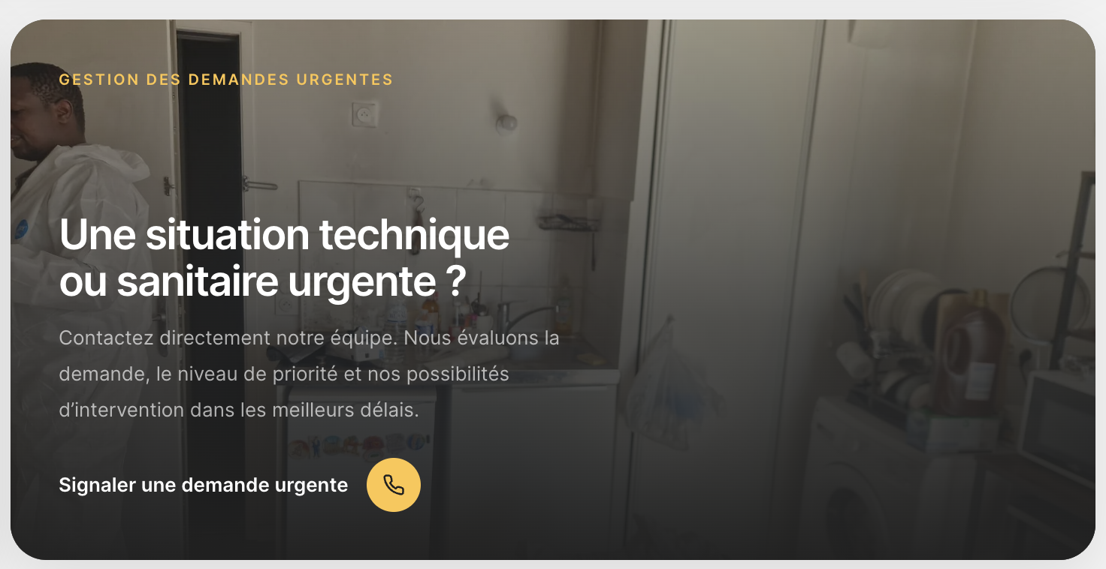

With this one named « Après » on the drive
